
Rose Mary College of Arts &Science (For Women)
Run by Rose Mary Educational Society
(Affiliated to Manonmaniam Sundaranar University)
Munnerpallam Village, Nagercoil Road, Principal : 2484200
Konganthanparai Post, Tirunelveli-627007 Office : 2484275, 9791325156
Email : rosemarycollege@gmail.com
Website : www.rosemarycollege.com

Department of Computer Science
Extension Activity Report
Visit to CMS Evangelical Primary School on 20.12.2021
A visit to CMS Evangelical Primary School was arranged on 20.12.2021 with 10 students from II BSc Computer Science,10 students from III BSc Computer Science and one staff member from the department of Computer Science at 11am. There our College students demonstrate the parts of the computer and the good habits that we have to follow in our daily life activities among the students of that school in a very effective and efficient manner.
Our College students have given gifts to the school students to encourage the good habits and given advice to them to improve their hygiene. This Gathering makes our students and the school students very happy and give a chance to share their computer skills among the school students.
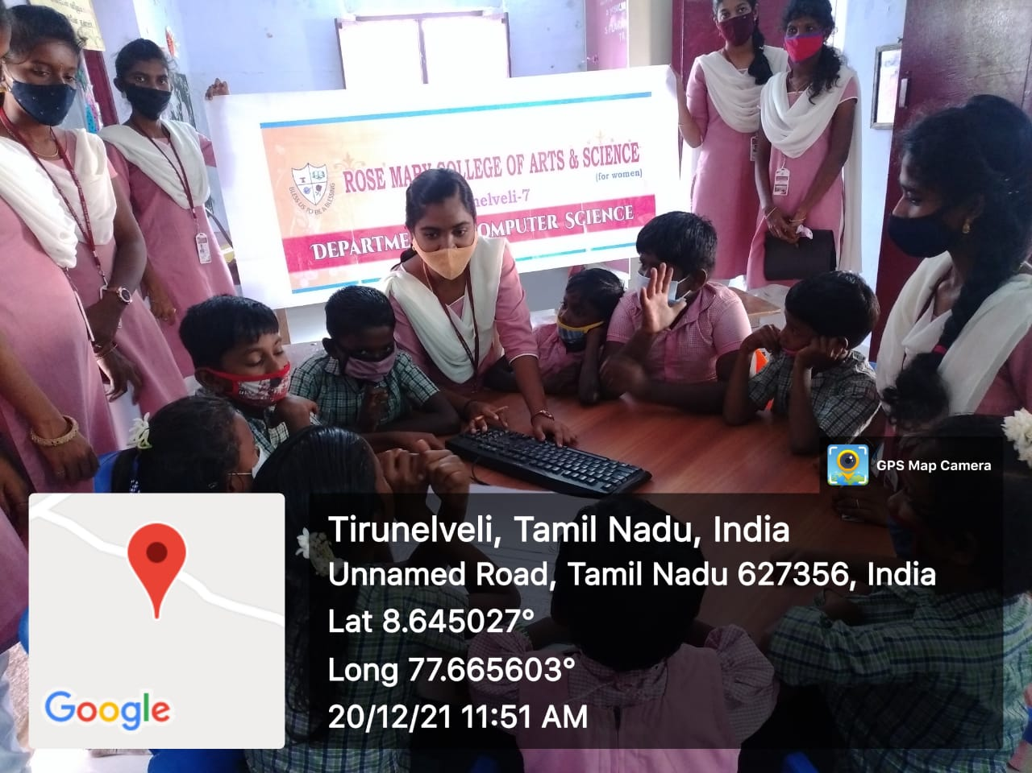
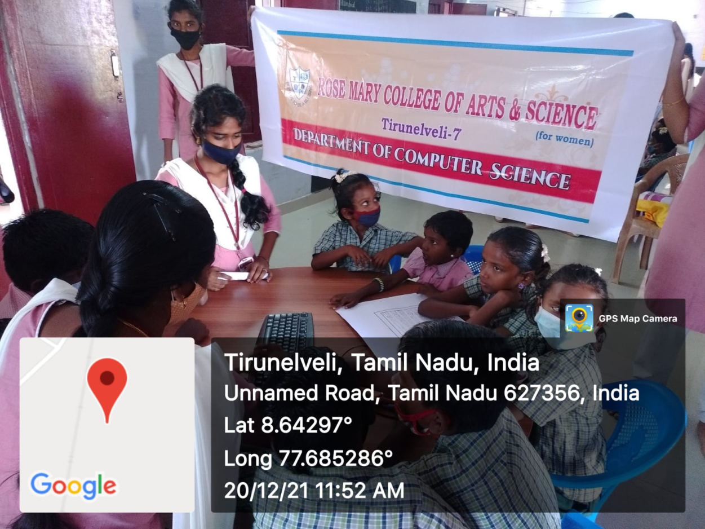
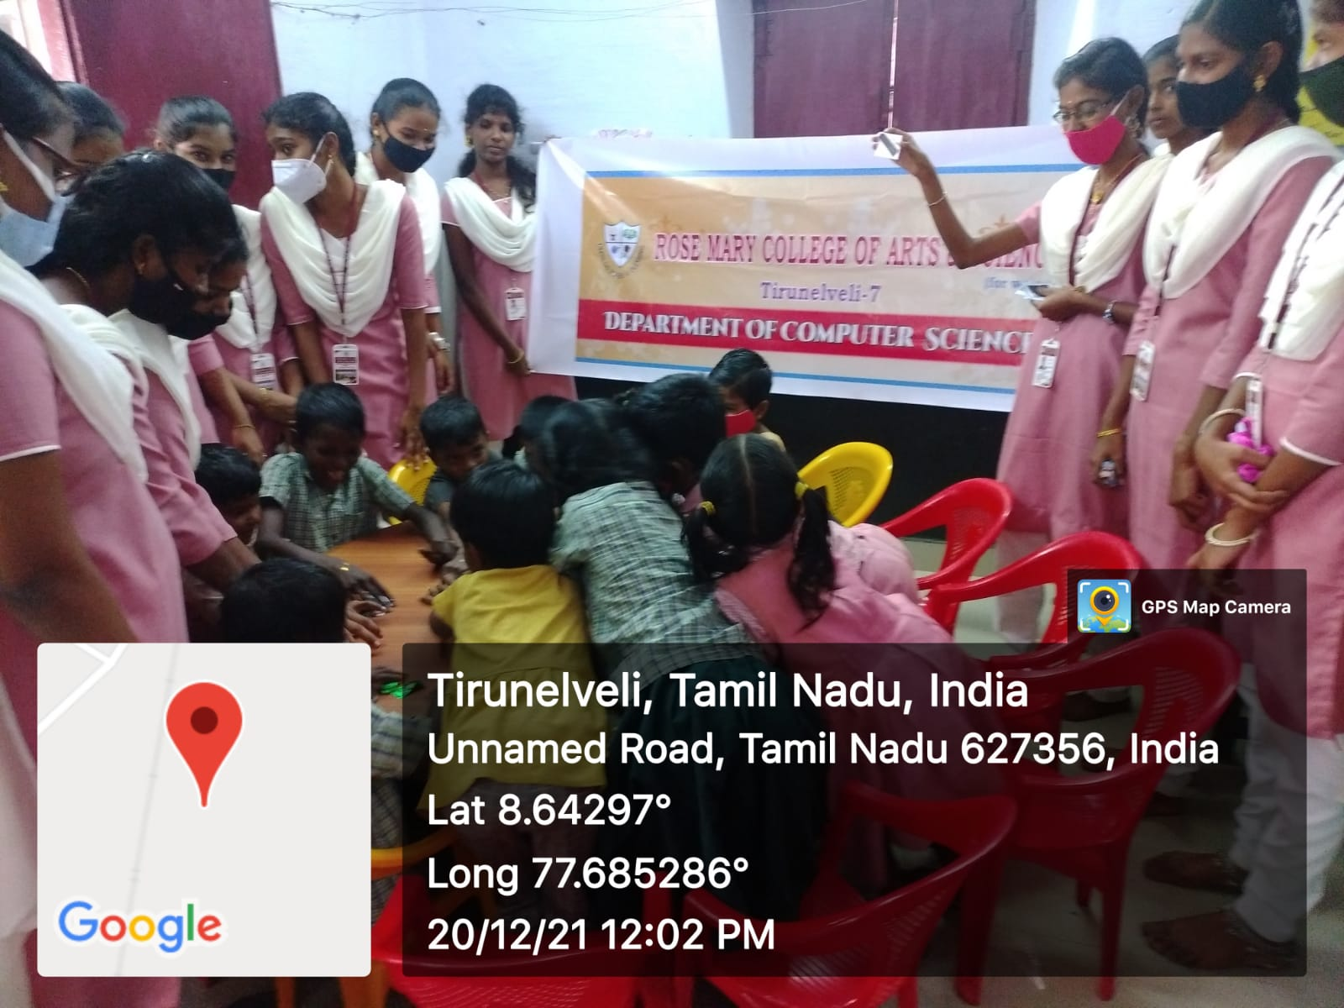
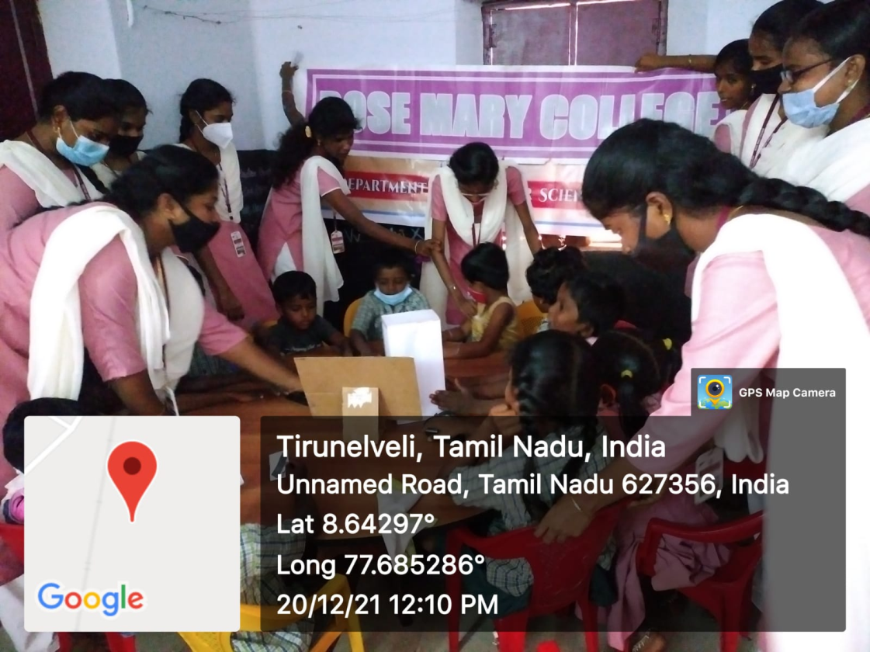
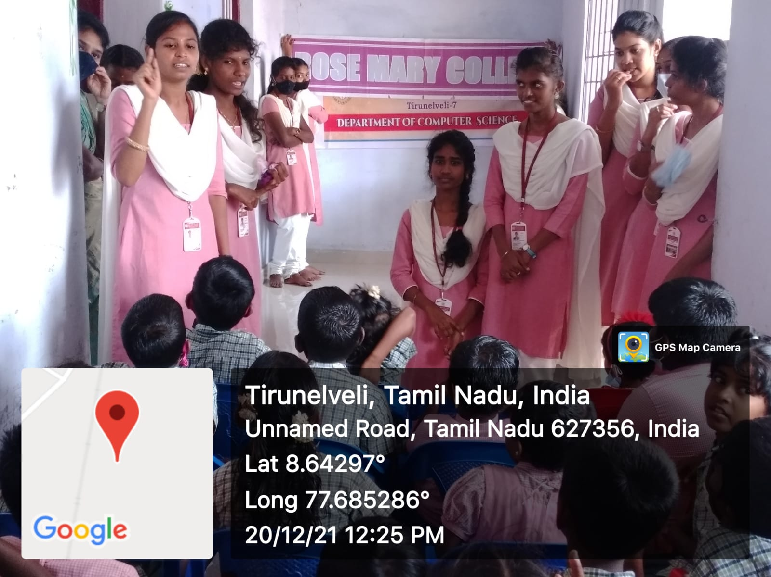

Signature of the HOD Signature of the Principal

