Extension Activity Report
Visit to Panchayat Union Primary School on 21.12.2021

A Visit to Panchayat Union Primary School was arranged on 21.12.2021 with 20 students from II B.Sc and III B.Sc Department of Mathematics and two staff members from the Department of Mathematics at 11.am.There our college students taught basic mathematics using chart materials. The class has been taken in an effective and efficient manner.
Our college Students have given gifts to the school students to encourage their activities. This gathering makes our students and the school students very happy and give a change to share their mathematic skills among the school students.

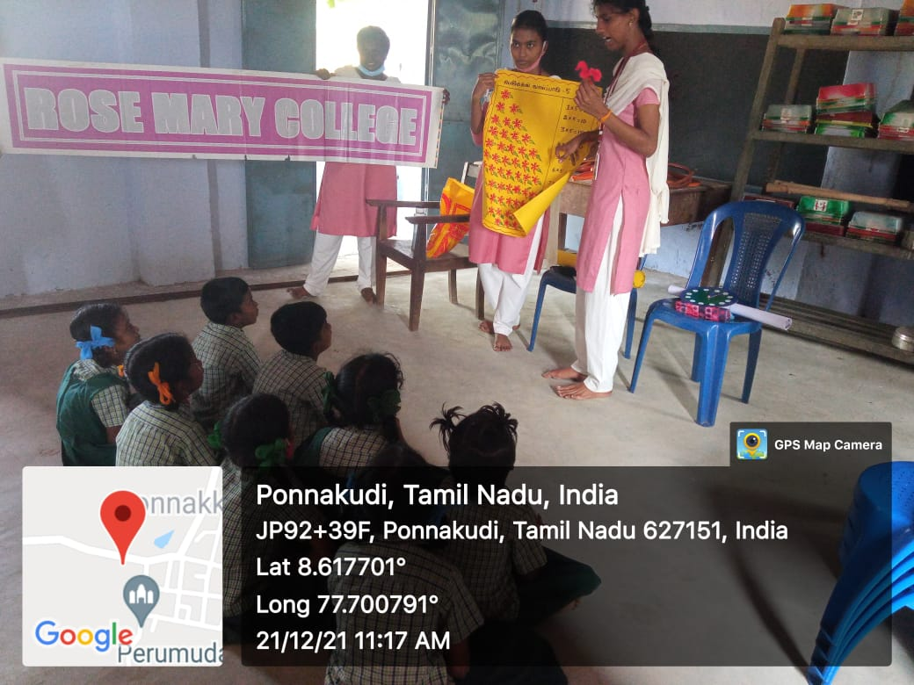

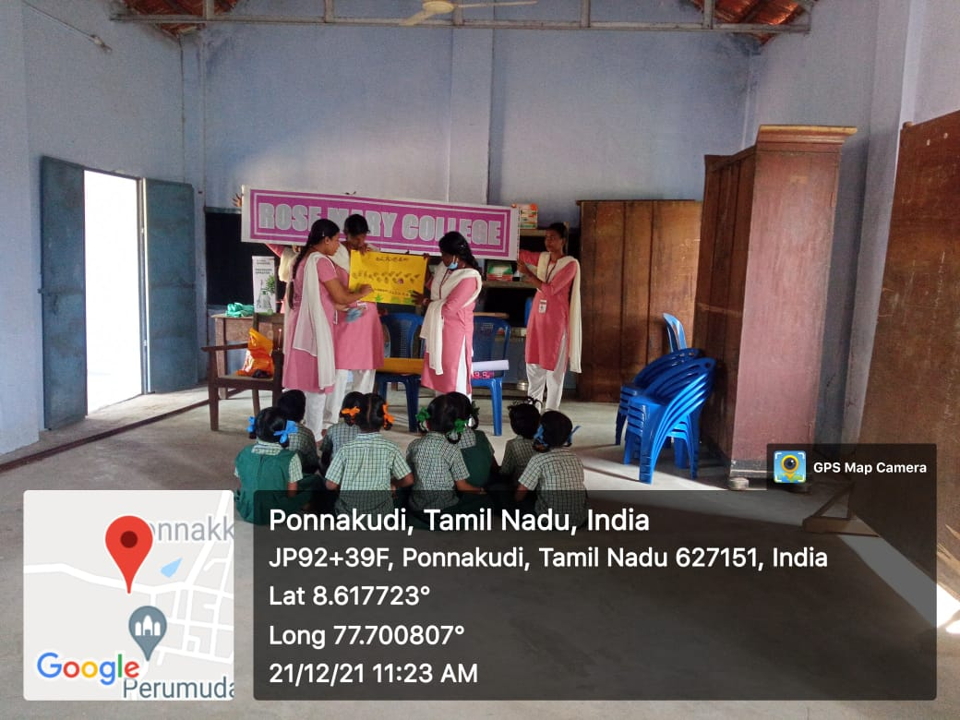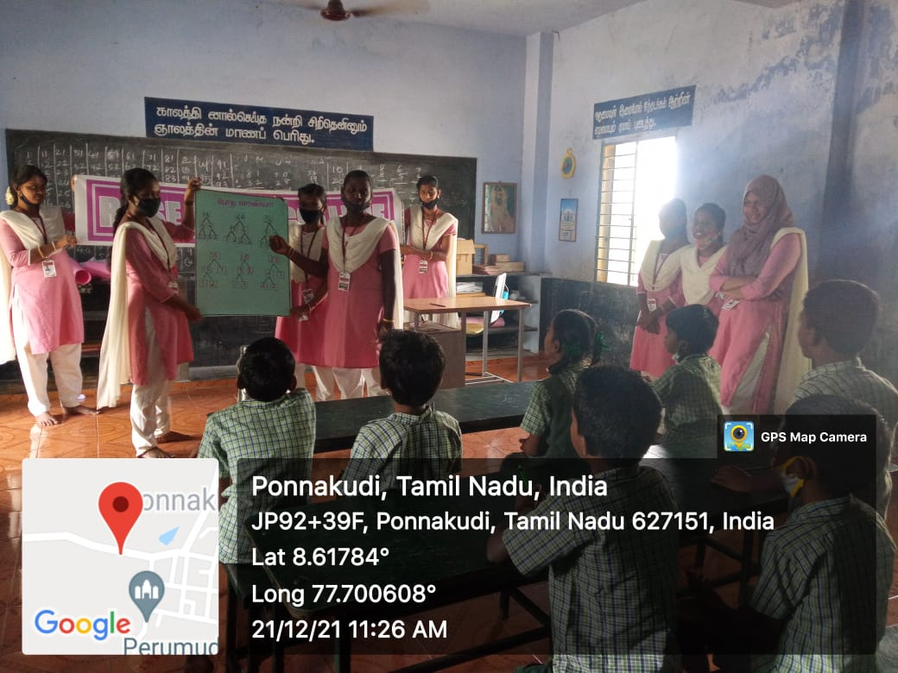
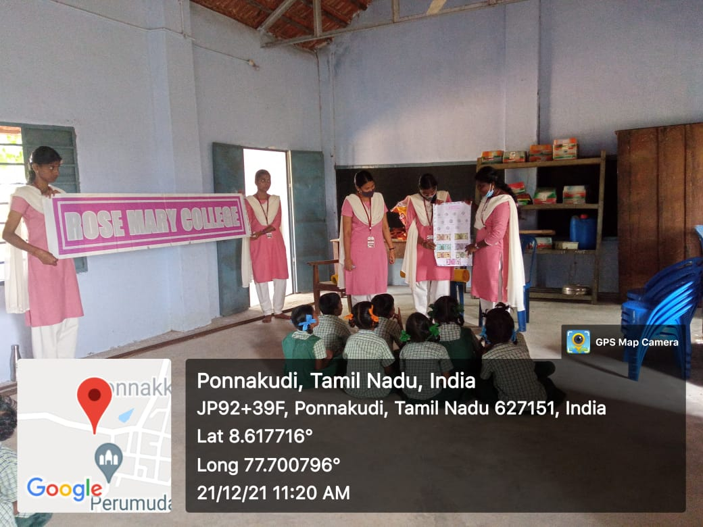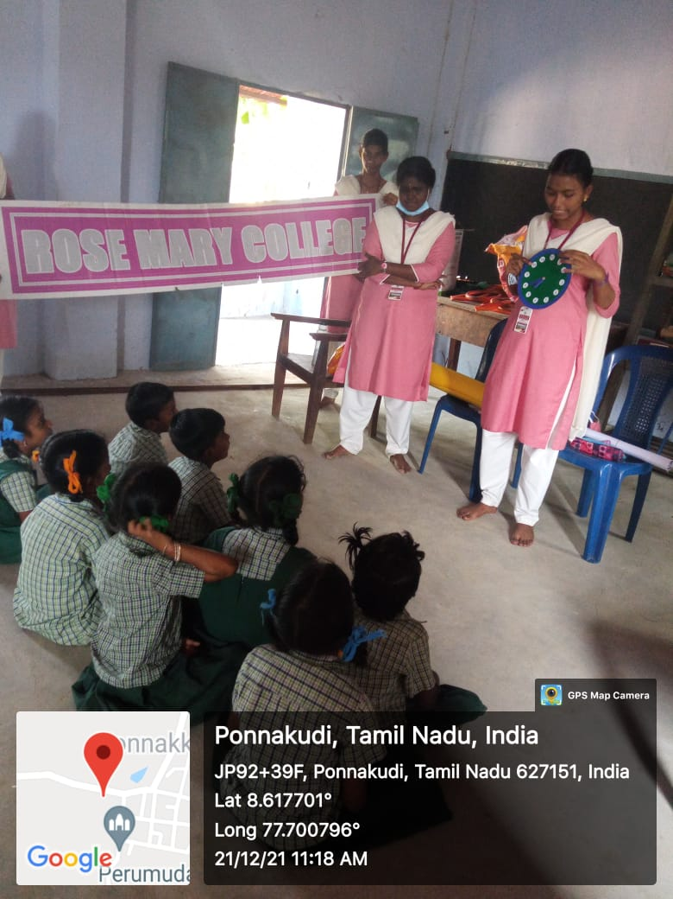

Signature of HOD Signature of Principal

